Communications toolkit:
Get to know where to go – mid to late summer edition.

Introduction

As we enter the school summer holidays and continually warm weather, it’s still crucial to prioritise our well-being and to take care of ourselves amidst potential rising temperatures and a pollen count that remains high. To ensure people stay healthy, we are continuing to encourage everyone to understand how best to stay safe in the sun, know where to go for support during the school holidays such as foodbanks, be up to date with vaccinations ahead of the new school term and foreign travel, and know the appropriate urgent care services if needed, including emergency hotlines – be that dental, eyecare or mental wellbeing.

With the August bank holiday just around the corner, we are also encouraging people to be prepared by ensuring they have enough of their repeat prescriptions (and know their local pharmacy opening times).

As the exam results season is fast approaching, we are also signposting to mental health support for both students and parents or carers of young people. This time of year can often be stressful which can lead to both young people and parents or carers feeling anxious or overwhelmed, so we are aiming to reassure those feeling the pressures that this is completely normal and that they don’t have to face it alone.

Get to know where to go campaign overview

NHS Greater Manchester’s Get To Know Where To Go campaign was launched in Winter 2022 and has been a trusted vehicle for carrying important and pertinent messaging around appropriate use of NHS services. The campaign focuses on enabling better, more effective decisions with straightforward and timely advice.

Please contact the NHS GM campaigns team if you have any questions – gmhscp.gm-campaigns@nhs.net.

How you can get involved

- Use the social media assets to schedule posts on your channels
- Promote the newsletter copy in your internal newsletters
- Share this toolkit with partner organisations and with stakeholder lists

Newsletter copy

Get prepared for the bank holiday and the new school term!

Summer and school holidays can be a busy time, and with so much going on in the run up to the August bank holiday it’s easy to forget the smaller things like making sure you get your repeat prescription to the pharmacy in good time and ensuring your child is up to date with their vaccinations prior to starting the new school year. By thinking ahead and re-stocking medicine cabinets, people can make sure they make the most of the bank holiday and are well-prepared for the busy period.

Although it can be great fun to bask in the sun and enjoy a BBQ with friends or family with a drink or two, there are a few simple things we can all do to stay safe. This includes looking out for those who may be struggling with the heat, taking precautions to protect your skin from harmful UV rays, staying cool indoors and avoiding physical exercise at peak times of the day (between 11am-3pm). It’s important to remember that although as summer draws to a close, the pollen count remains high so knowing where to go for allergy advice is vital.

It’s also crucial during this time of year to recognise the potential impact on mental health and alcohol related concerns. Summer can be a difficult time for people and whilst some enjoy time with friends and family at social gatherings or on holiday, others may experience feelings of loneliness, worry or anxiety. It’s important to look after yourself and others – remember that support is available to those how who may need it.

As pressure surrounding exam results builds, people are also reminded of the wealth of mental health support available for young people and their parents or carers. If either yourself or your child is finding the upcoming exam results period overwhelming, help is available. Whether it’s to help build resilience and stay mentally healthy when things are feeling challenging, to talk to someone about how you’re feeling, or to find out how best to support your child, lots of help and advice can be found from services such as Kooth, Silvercloud or Qwell.

People are reminded that:
The local pharmacy can offer advice and treatment for lots of minor illnesses, ailments and allergies - without the need for an appointment. Many will still be open over the bank holiday, but some will operate with reduced hours.

Dental support can be accessed via the Greater Manchester dental helpline (0333 332 3800), which is available from 8am to 10pm every day, including weekends and bank holidays for those who need help urgently when their practice is closed, or do not have a regular dentist.

Greater Manchester’s Urgent Eye Care Service can provide assessments and treatment quickly if a sudden change in vision, red or painful eyes or new flashes or floaters are seen. This is a free NHS service, made up of local optician teams. Available to anyone registered with a Greater Manchester GP. To find out more, visit www.primaryeyecare.co.uk

Mental health crisis support
Free 24/7 mental health crisis support is available across Greater Manchester.
For Bolton, Manchester, Salford, Trafford and Wigan residents, call 0800 953 0285.
For Bury, Heywood, Middleton and Rochdale, Oldham, Stockport, Tameside and Glossop the number is 0800 014 9995.

Free digital mental wellbeing support
Access free, safe, and anonymous professional support online. There are no waiting lists for support and no referral needed. Access to these platforms is available instantly 24/7. Support available includes: Live chat or messaging with qualified mental health professionals; self-help tools and activities; Visit Kooth (for ages 10 to 25) www.kooth.com or Qwell (for ages 26+) www.qwell.io/, Living Life To The Full and SilverCloud for adults 16yrs +
In addition to the above digital support offers, there are now two other free programmes available: SilverCloud’s programmes for parents and carers.
- Supporting an Anxious Child (for parents and carers of children aged 5 to 11)
- Supporting an Anxious Teen (for parents and carers of teenagers aged 12 to 18)
You can access these programmes here gm.silvercloudhealth.com/signup.

Services you can self-refer to
Find out about the range of mental health and wellbeing support services in Greater Manchester that you can self-refer to. There’s information on this page for children and young people and adults. Visit https://hub.gmintegratedcare.org.uk/mental-health/mental-health-and-wellbeing-support-in-greater-manchester-that-you-can-self-refer-to/

Alcohol addiction
Support is available to those who may need it. For services in your local area, visit www.nhs.uk/nhs-services/find-alcohol-addiction-support-services

Foodbanks
There are lots of foodbanks across Greater Manchester. Many of these services offer more than just food, some may offer support around mental health and wellbeing, food parcels, financial advice and support, community ran groups and much more. For help in your local area, visit www.greatermanchester-ca.gov.uk/helping-hand/food.

As always the first port of call for non-emergency health needs should be NHS 111 Online or call 111.

Social media assets:

All assets can be found on the following download link: GOOGLE DRIVE. Please do not use the low-resolution positional images used in the table below, these are for reference only.

To be used throughout JULY and AUGUST.

Asset | Long copy (Facebook and Instagram) | Short copy 280 characters (Twitter) | Alt text
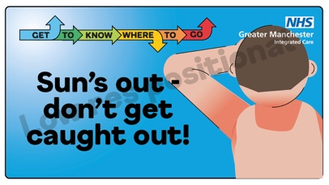 | Sunburn can be really sore, but it’s easy to treat at home.  🚿 cool your skin with a shower, bath or damp towel  🧴 apply aftersun cream or spray  👕 cover the skin until it’s fully healed  For help with sunburn: 👉 www.nhs.uk/conditions/sunburn  #GTKWTG | Sunburn can be really sore, but it’s easy to treat at home.  🚿 cool your skin with a shower, bath or damp towel  🧴 apply aftersun cream or spray  👕 cover the skin until it’s fully healed  For help with sunburn: 👉 www.nhs.uk/conditions/sunburn  #GTKWTG | Visual contains an image of a person with sunburn. Text reads, sun’s out – don’t get caught out. Get to know where to go.
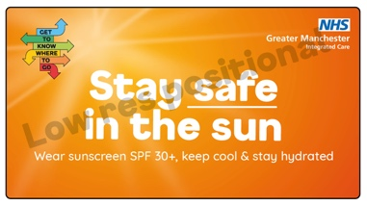 | It’s a scorcher! Remember - there’s no safe or healthy way to get a tan, so take care out there.  ☂️ Find shade between 11am and 3pm  🧴 Wear at least SPF30 sunscreen  👪 Take extra care with children  👕 Cover up with suitable clothing and a hat  Stay safe in the sun 👉 www.nhs.uk/live-well/seasonal-health/sunscreen-and-sun-safety.  #GTKWTG | It’s a warm one so take care out there!  ☂️ Find shade between 11am and 3pm  🧴 Wear at least SPF30 sunscreen  👪Take extra care with children  👕 Cover up with suitable clothing and a hat  Stay safe in the sun 👉 www.nhs.uk/live-well/seasonal-health/sunscreen-and-sun-safety.  #GTKWTG | Visual contains text only. Text reads, stay safe in the sun. Wear sunscreen SPF 30+, keep cool and stay hydrated. Get to know where to go.

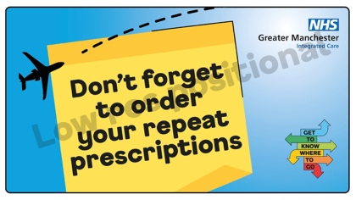 | It’s holiday season! ⛱️  If you take regular medicines on repeat prescription, make sure you have enough to last the whole trip and order them in plenty of time before you go.  You can now order repeat prescriptions quickly and easily online. Visit www.gmintegratedcare.org.uk/rememberprescriptions  #GTKWTG | It’s holiday season! ⛱️  If you take regular medicines on repeat prescription, make sure you have enough to last the whole trip and order them in plenty of time before you go.  Order repeat prescriptions quickly and easily online www.gmintegratedcare.org.uk/rememberprescriptions  #GTKWTG | Visual contains image of an aeroplane. Text reads don’t forget to order your repeat prescriptions. Get to know where to go.
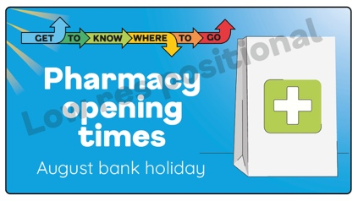 | Your local #pharmacy may have different opening hours over the August bank holiday weekend ⏲️  See which pharmacy is open closest to you: gmintegratedcare.org.uk/bank-holiday-services.  #GTKWTG | Your local #pharmacy may have different opening hours over the August bank holiday weekend ⏲️  See which pharmacy is open closest to you: gmintegratedcare.org.uk/bank-holiday-services.  #GTKWTG | Visual contains image of a pharmacy bag. Text reads, pharmacy opening times. August bank holiday. Get to know where to go.
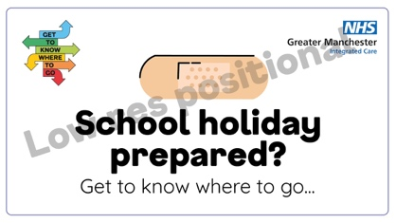 | School holidays are a great time for kids to have fun outdoors, but sadly accidents can happen 🩹  Whether it's a bump, bruise, graze or sprain - there's advice and tips to help at www.gmintegratedcare.org.uk/GTKWTG  If in doubt, visit 111.nhs.uk or your local pharmacy.  #GTKWTG | School holidays are a great time for kids to have fun outdoors, but sadly accidents happen 🩹  Whether it's a bump, bruise, graze or sprain - there's advice and tips to help at www.gmintegratedcare.org.uk/GTKWTG  If in doubt, visit 111.nhs.uk or your local pharmacy.  #GTKWTG | Visual contains image of a plaster. Text reads, school holiday prepared? Get to know where to go.

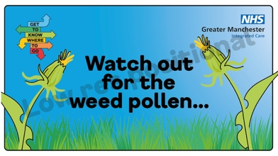 | We’re finally starting to see less pollen however during August, weed pollen allergies might cause hay fever symptoms to return 🤧  Weed pollen can cling to laundry as it dries so if you’re tempted to hang washing outside, pop on some sunglasses to help to keep pollen out of your eyes. You can usually treat #allergies with antihistamine medication available at pharmacies.  Find your nearest pharmacy 👉 nhs.uk/find-a-pharmacy  #GTKWTG | We’re finally starting to see less pollen however during August, weed pollen allergies might cause hay fever symptoms to return 🤧  You can usually treat #allergies with antihistamine medication available at pharmacies. Find your nearest pharmacy 👉 nhs.uk/find-a-pharmacy  #GTKWTG | Visual contains images of weeds and grass. Text reads, watch out for the weed pollen…
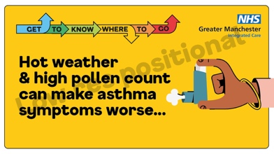 | If you have #asthma then a high pollen count and warm weather can affect your condition.  Always carry an inhaler and don’t leave it in direct sunlight.  If you’re struggling to manage your asthma, speak to your GP. For more info visit www.nhs.uk/conditions/asthma.  #GTKWTG | If you have #asthma then a high pollen count and warm weather can affect your condition.  Always carry an inhaler and don’t leave it in direct sunlight.  If you’re struggling to manage your asthma, speak to your GP. For more info visit www.nhs.uk/conditions/asthma.  #GTKWTG | Visual contains an image of a person’s arm holding an inhaler. Text reads, hot weather and high pollen count can make asthma symptoms worse… Get to know where to go.

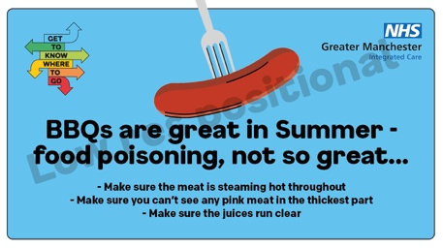 | Warm weather and BBQs go hand in hand, but outdoor cooking can be the perfect conditions for bacteria to grow 🤢  Avoid any upset tummies! 👉 www.food.gov.uk/safety-hygiene/bbq-food-safety  If you feel unwell visit 👉 www.gmintegratedcare.org.uk/GTKWTG and download our handy NHS services booklet. #GTKWTG | Warm weather and BBQs go hand in hand, but outdoor cooking can be the perfect conditions for bacteria to grow 🤢  Avoid any upset tummies! 👉 www.food.gov.uk/safety-hygiene/bbq-food-safety  If you feel unwell visit 👉 www.gmintegratedcare.org.uk/GTKWTG and download our handy NHS services booklet. | Visual contains image of person’s hand holding a fork with a sausage on the fork. Text reads, BBQs are great for summer – food poisoning, not so great. Make sure the meat is steaming hot throughout. Make sure you can’t see any pink meat in the thickest part. Make sure the juices run clear. Get to know where to go.
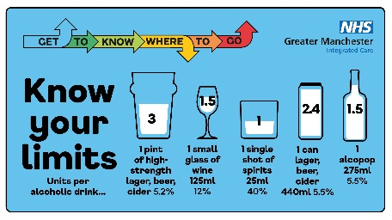 | Summer is fantastic, but it’s important to know the dangers of drinking too much. Please drink responsibly and know your limits.  If you or someone you know struggles with #alcohol, help is available. Find local support 👉 www.nhs.uk/nhs-services/find-alcohol-addiction-support-services. #GTKWTG | Summer is fantastic, but it’s important to know the dangers of drinking too much. Please drink responsibly and know your limits.  If you or someone you know struggles with #alcohol, help is available. Find local support 👉 www.nhs.uk/nhs-services/find-alcohol-addiction-support-services. #GTKWTG | Visual contains image of different sized glasses. Text reads know your limits. Units per alcoholic drink…1 pint of high-strength lager, beer, cider 5.2%. 1 small glass of wine 125ml 12%. 1 single shot of spirits 25mh 40%. 1 can lager, beer, cider 440ml 5.5%. 1 alcopop 275ml 5.5%. Get to know where to go.
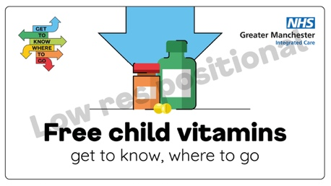 | Don’t miss out on a Healthy Start for your family!  💊 FREE vitamin tablets and drops  💳 Help to buy fruit and vegetables and milk  For more info – including eligibility - ask your midwife or health visitor, or go to www.healthystart.nhs.uk #GTKWTG | Don’t miss out on a Healthy Start for your family!  💊 FREE vitamin tablets and drops  💳 Help to buy fruit and vegetables and milk. For more info – including eligibility - ask your midwife or health visitor, or go to www.healthystart.nhs.uk #GTKWTG | Visual contains image of vitamin bottles. Text reads, free child vitamins. Get to know where to go.

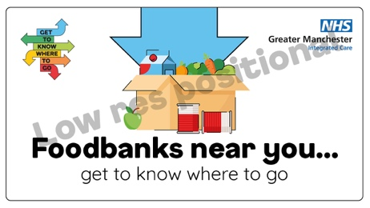 | For localities/districts  During school holidays, you may want to get some help from your local #foodbank 🍏  Here in (locality) we have (link to go in here) but there are lots of foodbanks across Greater Manchester, many of which offer more than just food.  Visit 👉 www.greatermanchester-ca.gov.uk/helping-hand/food.  #GTKWTG | For localities/districts  During school holidays, you may want to get some help from your local #foodbank 🍏  Here in (locality) we have (link to go in here) but there are lots of foodbanks across Greater Manchester, many of which offer more than just food.  Visit 👉 www.greatermanchester-ca.gov.uk/helping-hand/food.  #GTKWTG | Visual contains image of a box filled with food items. Text reads, foodbanks near you…get to know where to go.
 | For other partners  During school holidays, you may want to get some help from your local #foodbank 🍏  There are lots of foodbanks across Greater Manchester, many of which offer more than just food.  Visit 👉 www.greatermanchester-ca.gov.uk/helping-hand/food.  #GTKWTG | For other partners  During school holidays, you may want to get some help from your local #foodbank 🍏  There are lots of foodbanks across Greater Manchester, many of which offer more than just food.  Visit 👉 www.greatermanchester-ca.gov.uk/helping-hand/food.  #GTKWTG | Visual contains image of a box filled with food items. Text reads, foodbanks near you…get to know where to go.
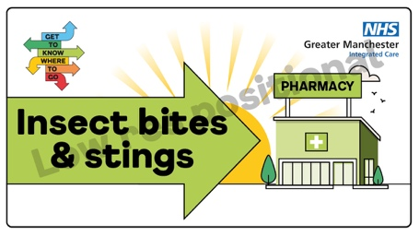 | Insect #bites and #stings aren’t usually serious and get better in a few days, but sometimes they can become infected or cause an allergic reaction 🐝  A pharmacist can advise on how to ease your symptoms. Find your nearest pharmacy 👉 nhs.uk/find-a-pharmacy. If your symptoms worsen, call 111 or visit 111.nhs.uk.  #GTKWTG | Insect #bites and #stings aren’t usually serious but sometimes they can become infected or cause an allergic reaction 🐝  A pharmacist can advise on how to ease your symptoms 👉 nhs.uk/find-a-pharmacy  If your symptoms worsen, call 111 or visit 111.nhs.uk. #GTKWTG | Visual contains image of a pharmacy building, text reads insect bites and stings.
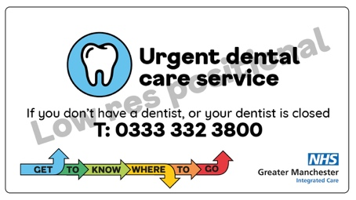 | If you have pain in your mouth, teeth or gums contact your dentist.  If your dentist is closed or you don’t have a regular dentist, call the Greater Manchester Urgent Dental Care Service on 0333 332 3800.  #GTKWTG | If you have pain in your mouth, teeth or gums contact your dentist.  If your dentist is closed or you don’t have a regular dentist, call the Greater Manchester Urgent Dental Care Service on 0333 332 3800.  #GTKWTG | Visual contains image of a tooth. Text reads urgent dental care service. If you don’t have a dentist or your dentist is closed, call 0333 3323800.

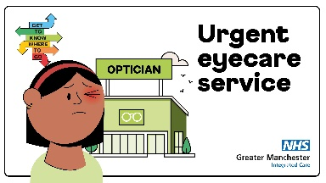 | Greater Manchester Urgent Eye Care Service can provide assessments and treatment quickly if you experience a sudden change in your vision, red or painful eyes or see new flashes or floaters across your eyes 👁️  It’s a free NHS service, made up of local optician teams in your area, which is available to anyone registered with a Greater Manchester GP.  Find out more 👉 www.primaryeyecare.co.uk | Have you recently started to suffer with sore red eyes, noticed a sudden change in your #vision such as flashes or floaters across your eyes? Then Greater Manchester’s Urgent Eye Care Service might be for you 👁️  👉 www.primaryeyecare.co.uk  #GTKWTG | Visual contains image of a person closing one eye in pain stood in front of an opticians building. Text reads urgent eyecare service.
 | Are your child's vaccinations up to date ready for the new school term?  It's important that vaccines are given on time for the best protection - but it's never too late to catch up!  Contact your GP practice to book an appointment.  Find out what they need to have and when: www.nhs.uk/conditions/vaccinations/nhs-vaccinations-and-when-to-have-them  #GTKWTG | Are your child's vaccinations up to date ready for the new school term?  It's important that vaccines are given on time for the best protection - but it's never too late to catch up!  Contact your GP practice to book an appointment.  Go to: www.nhs.uk/conditions/vaccinations/nhs-vaccinations-and-when-to-have-them  #GTKWTG | Visual contains image of a red school backpack, text reads school ready…is your child up to date with their vaccinations?
 | Are you traveling abroad soon? You might need travel #vaccinations ✈️💉  Vaccinations need to be planned in at least 6-8 weeks before you jet away, contact your GP or travel clinic for more info.  #GTKWTG | Are you traveling abroad soon? You might need travel #vaccinations ✈️💉  Vaccinations need to be planned in at least 6-8 weeks before you jet away, contact your GP or travel clinic for more info.  #GTKWTG | Visual contains image of a sun and an aeroplane. Text reads, going abroad? Check if you need travel vaccinations. Travel vaccinations need to be planned in at least 6-8 weeks before travel. Speak to your GP or travel clinic.

Mental health and exam results support

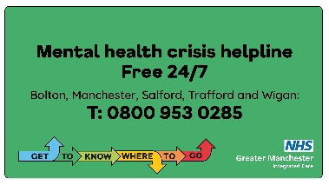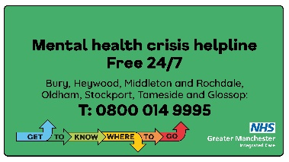 | Please remember - the mental health crisis helpline is there if you are concerned about yourself, a loved one, neighbour, friend or family member.  It’s open 365 days per year and is free of charge.  Visit 👉 www.gmintegratedcare.org.uk/GTKWTG.  #GTKWTG | Please remember - the mental health crisis helpline is there if you are concerned about yourself, a loved one, neighbour, friend or family member.  It’s open 365 days per year and is free of charge.  Visit 👉 www.gmintegratedcare.org.uk/GTKWTG.  #GTKWTG | Visual contains text only. Text reads, mental health crisis helpline, free 24/7. Bolton, Manchester, Salford Trafford and Wigan: call 0800 953 0285Get to know where to go.  Visual contains text only. Text reads, mental health crisis helpline, free 24/7. Bury, Heywood, Middleton and Rochdale, Oldham, Stockport, Tameside and Glossop: call 0800 014 9995. Get to know where to go.
 | For many students, #resultsday can be a stressful time. If you need support or a safe space to talk, #Kooth is available.  Access anonymous support when you need it.  Visit www.kooth.com  #GTKWTG | For many students, #resultsday can be a stressful time. If you need support or a safe space to talk, #Kooth is available.  Access anonymous support when you need it.  Visit www.kooth.com  #GTKWTG | Visual contains image of person sat on the floor. Text reads, exam results day. Whatever happens, we’ll be by your side. Find support on kooth.com today.
 | It’s normal to feel worried about #examresults. Exam stress can cause you to feel anxious and this might affect your sleeping or eating habits. If you recognise these feelings or are worried that exam pressure is taking over your life, you are not alone.  For support 👉 www.youngminds.org.uk/young-person/coping-with-life/exam-stress.  #GTKWTG | It’s normal to feel worried about #examresults. Exam stress can cause you to feel anxious which might affect your sleeping or eating habits. If you're worried, you are not alone.  For support 👉 www.youngminds.org.uk/young-person/coping-with-life/exam-stress.  #GTKWTG | Visual contains text only. Text reads young minds, the voice for young people’s mental health and wellbeing.
 | Exam results stress can have a huge impact on your child’s #mentalhealth and you may not know best how to fully support them.  Silvercloud offers help for parents and carers of teenagers aged 12 - 18, looking to support their teen in dealing with worry and anxiety, while learning strategies to tackle their own anxiety.  Head to 👉 gm.silvercloudhealth.com/signup  #GTKWTG | Exam results stress can have a huge impact on your child’s #mentalhealth.  Silvercloud offers help for parents and carers of teenagers aged 12 – 18 👉 gm.silvercloudhealth.com/signup  #GTKWTG | Visual contains image of person crossing arms smiling. Text reads, are you a parent to an anxious child or teen? The Silvercloud platform is here to help.
 | If you feel you need support, Childline’s Calm Zone has a lot of breathing exercises, activities, games and videos to help let go of stress. Just head to www.childline.org.uk/toolbox/calm-zone.  #GTKWTG | If you feel you need support, Childline’s Calm Zone has a lot of breathing exercises, activities, games and videos to help let go of stress. Just head to www.childline.org.uk/toolbox/calm-zone.  #GTKWTG | Visual contains text only. Text reads Childline, online, on the phone, anytime.

Please contact the NHS GM campaigns team if you have any problems downloading from the links provided – gmhscp.gm-campaigns@nhs.net.

